**CS628 Full-Stack Development II – Backend**

**PE03 - Basic Node and Express - Serve an HTML File**

Developed by Clark Ngo on December 29, 2020

School of Technology & Computing (STC)

City University of Seattle (CityU)

**Before You Start**

* Some steps are not explained in the tutorial**.** If you are not sure what to do:
  1. Consult the resources listed below.
  2. If you cannot solve the problem after a few tries, ask a TA for help.

**Learning Outcomes**

Students will be able to:

* Learn Basics of Node and Express

**Resources**

* https://www.freecodecamp.org/learn/apis-and-microservices/basic-node-and-express/serve-an-html-file

**How to Submit**

* **Upload .zip file**
* **Write a 150-word summary to explain your understandings and findings from this lab assignment.**

## **Basic Node and Express - Serve an HTML File**

You can respond to requests with a file using the res.sendFile(path) method. You can put it inside the app.get('/', ...) route handler. Behind the scenes, this method will set the appropriate headers to instruct your browser on how to handle the file you want to send, according to its type. Then it will read and send the file. This method needs an absolute file path. We recommend you to use the Node global variable __dirname to calculate the path like this:

absolutePath = __dirname + relativePath/file.ext

Send the /views/index.html file as a response to GET requests to the / path. If you view your live app, you should see a big HTML heading (and a form that we will use later…), with no style applied.

1. Start a new project on Repl.it using [this link](https://repl.it/github/freeCodeCamp/boilerplate-express).
2. Click Run to test your code

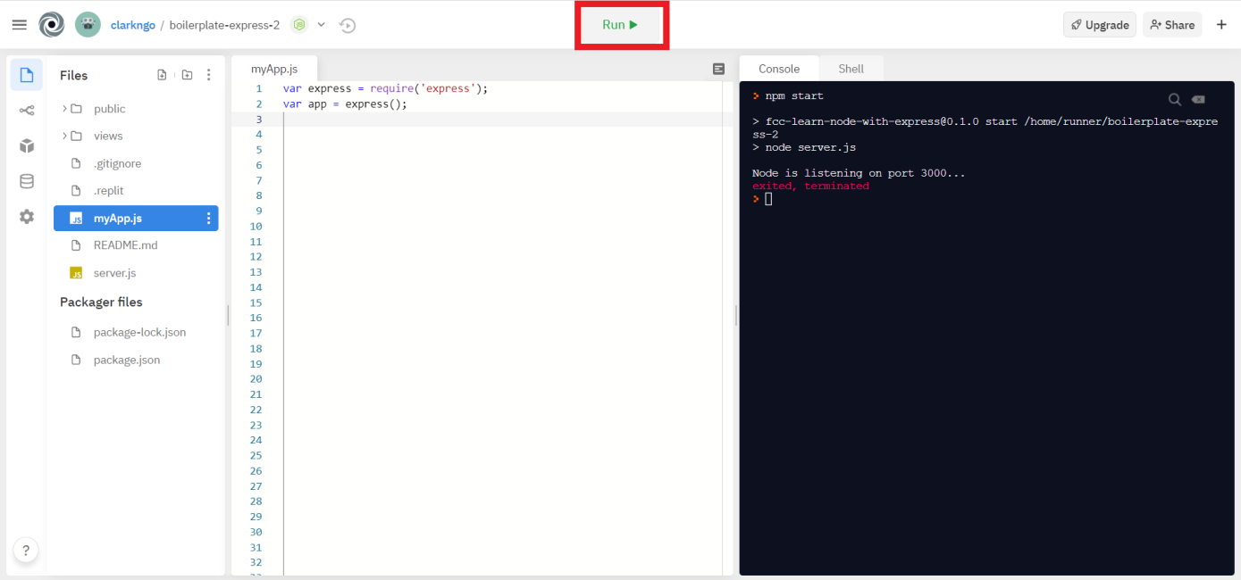

1. Download the project as .zip.

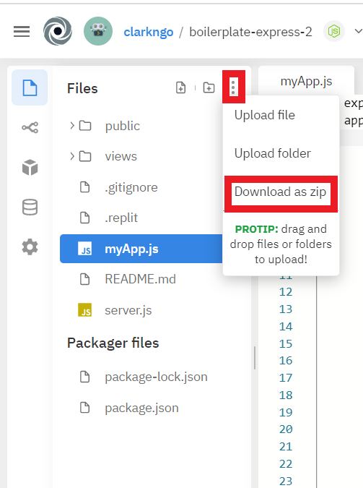

1. In BlackBoard, upload the .zip file and write a 150-word summary to explain your understandings and findings from this lab assignment.

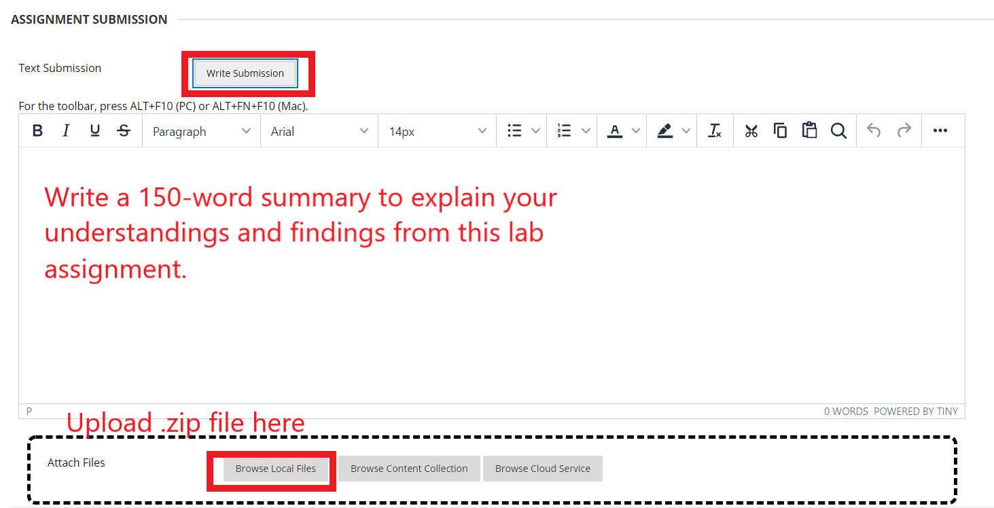

Last week we called the express’s app.get method to interface with the express framework. When we get a request from the client, our function gets triggered. And we send a response to the client. Last we we sent a string “Hello Express” to the client. This week we need to send a file to the client instead. So instead of using the res.send method, we use res.sendFile method. First part of the parameter is __dirname which corresponds to the root directory of the project. Second part of the parameter is "/public/index.html" which corresponds to the path, filename, and file extension of the file we are sending back to the user. As a result, the client gets the html page. The html page contains a title, link to the css, a header, a paragraph, and a form with labels, text fields, and a button. If we take a look at the action attribute of the form element shows us that this form should trigger and send its data to /name url of the server. This url probably corresponds to a controller.